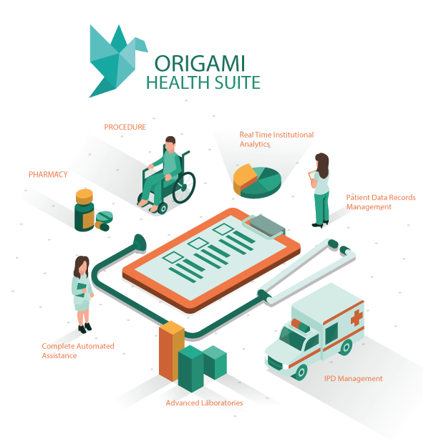
ORIGAMI HEALTH SUITE



Manual for HEALTH SUITE

ORIGAMI Digital Solutions and Consulting
Contents
1. Purpose 4
2. Scope of the Health Suite Manual 5
3. Key Definitions 7
4. Stakeholders 8
5. About Origami Health Suite 10
5.1 Introduction 10
5.2 Core Modules: 11
6. Admin Login 12
6.1 Admin Dashboard – Module & Configuration Access 12
7. Configurer Module 14
8. OPD 18
9. IPD 24
10. Procedure 27
11. Patient Record Data System 30
12. Lab Revive 33
13. Access Controls, Privacy and Security 40
13.1 Privacy 40
13.2 Security 40
13.3 Access Control 40

- Purpose
Origami’s Health Suite is a comprehensive, solution based Healthcare Management Platform designed to streamline and digitize operations across hospitals and clinics. The solution integrates multiple functional modules into a single, unified system, enabling healthcare facilities to efficiently manage clinical, administrative, and financial workflows.
Origami Health Suite addresses the challenges faced by healthcare institutions due to fragmented systems and manual processes. By consolidating all critical hospital operations under one platform, it ensures seamless data flow, improved operational efficiency, and enhanced patient care.
The platform consists of the following integrated modules:
- OPD (Outpatient Department)
- IPD (Inpatient Department)
- Laboratory (Legacy & Revive)
- Procedure Management
- Pharmacy
- Patient Data Record System
- Accounts
- Configurer
Each module is designed to function independently while remaining fully integrated within the Health Suite ecosystem. The Patient Data Record System serves as the core component, ensuring centralized and structured patient information management. The OPD and IPD modules handle complete patient lifecycle management, from registration to discharge. Laboratory modules support diagnostic workflows, while Pharmacy and Accounts streamline medicine dispensing and financial operations. The Configurer module enables customization and configuration based on institutional requirements.
Health Suite ensures structured data capture, real-time updates, and secure record maintenance. The system enhances data accuracy, supports administrative oversight, and enables healthcare facilities to monitor operations across departments efficiently.
By integrating clinical, diagnostic, pharmaceutical, and financial processes into a single platform, Origami’s Health Suite delivers a scalable, reliable, and efficient digital solution for modern healthcare facilities, improving service delivery while maintaining regulatory and operational compliance.

- Scope of the Health Suite Manual
The Health Suite User Manual serves as a comprehensive operational guide for healthcare administrators, doctors, laboratory staff, pharmacists, and accounts personnel using Origami’s Health Suite platform. The manual is designed to ensure efficient navigation and effective utilization of all integrated modules within the system.
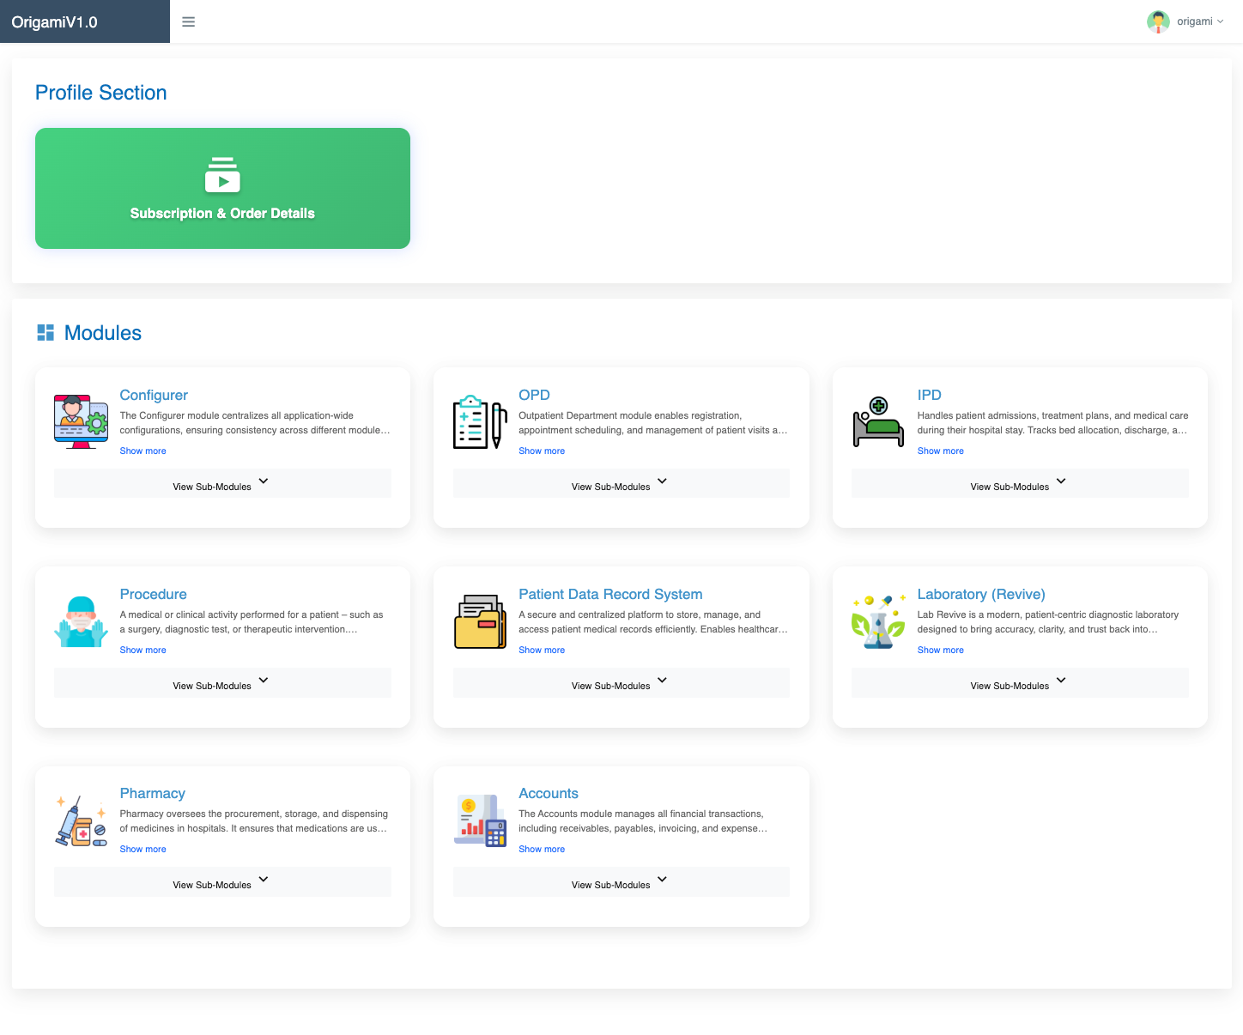
This document provides detailed, module-wise instructions covering OPD, IPD, Laboratory (Legacy & Revive), Procedure Management, Pharmacy, Patient Data Record System, Accounts, and Configurer. It offers step-by-step workflows, role-based access guidelines, and process explanations to help healthcare facilities manage clinical, diagnostic, administrative, and financial operations seamlessly.
Health Suite provides a unified, web-based interface that eliminates the need for multiple disconnected systems. All patient-related information — from registration and consultation to diagnostics, pharmacy dispensing, billing, and accounting — is managed within a single integrated platform. This ensures real-time data availability, improved coordination between departments, and reduced operational delays.
By consolidating healthcare services into one comprehensive system, Health Suite enhances data accuracy, operational transparency, and overall institutional efficiency. The platform supports healthcare facilities in delivering improved patient care while maintaining structured record management and streamlined administrative processes.

- Key Definitions
Acronym/Key Word | Definition
OPD | Outpatient Department – Manages patient consultations, doctor appointments, visit records, prescriptions, and outpatient billing processes.
IPD | Inpatient Department – Handles patient admissions, bed allocation, treatment records, nursing notes, procedures, discharge summaries, and inpatient billing.
LAB | Laboratory Module – Manages diagnostic test registration, sample collection, processing, result entry, validation, and report generation (Legacy & Revive).
RBAC | Ensures that users are granted access to specific modules and functionalities based on their designated roles (Administrator, Doctor, Receptionist, Lab Technician, Accounts, etc.), maintaining data security and operational control.
IAM | Provides centralized user authentication and authorization management. IAM ensures secure login, user identity verification, password policies, session management, and controlled access across all Health Suite modules.

- Stakeholders
Stakeholders
Administrator | System Administrators are responsible for the overall management of the Health Suite platform within the healthcare institution. They oversee user creation, role assignments, module activation, system configuration, and security controls.  The core functionality of the Administrators ensure master management across all modules, maintain configuration of modules with the selected Roles, and monitor system performance .
Configurer | Authorized Configurer users manage master data and system settings within Health Suite. Onboarding of the Healthcare Suite onto different Institutions. This includes configuring Masters, different Rooms services, test parameters, billing heads, user roles, tariffs, and workflow rules. They ensure that the platform is customized as per the hospital’s operational requirements while maintaining standardized processes and compliance.
Receptionist (Front Desk/OPD Desk) | Receptionists manage patient registration, appointment scheduling, OPD/IPD admissions, and initial billing processes. They create and maintain patient records within the Patient Data Record System via Web Interface or  Customized Mobile Platform, ensuring accurate demographic and contact information. Their role is critical in initiating the patient care journey and ensuring smooth coordination between departments.
Accounts | Accounts personnel handle billing, payment collection, invoice generation, refunds, insurance entries (if applicable), and financial reporting. They ensure accurate recording of transactions related to consultations, procedures, laboratory tests, pharmacy sales, and inpatient services. The Accounts module supports transparent financial management and reconciliation.
Laboratory | Laboratory staff manage diagnostic workflows, including test registration, sample collection, processing, result entry, validation, and report generation. The Laboratory module (Legacy & Revive) enables structured test management, parameter-wise result entry, and secure report access. Lab personnel ensure accuracy, timely reporting, and proper coordination with doctors and patients.

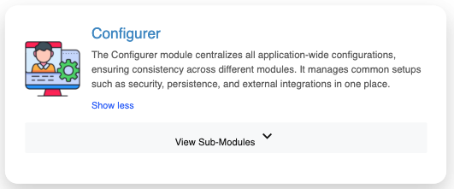
- About Origami Health Suite
  - Introduction
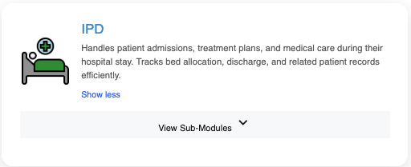
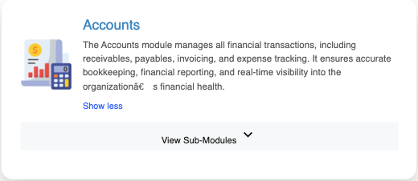
The Health Suite is a comprehensive healthcare management platform developed by Origami Digital Solutions and Consulting to streamline and digitize hospital and clinic operations. The system provides a centralized, Web and Mobile Based solution that enables healthcare facilities to efficiently manage patient records, clinical workflows, diagnostics, pharmacy operations, and financial transactions within a single integrated environment.
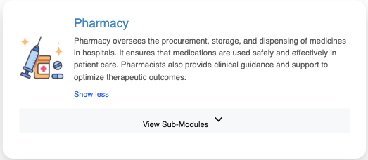
By leveraging modern technology, Health Suite eliminates fragmented systems and manual paperwork, ensuring faster data processing, improved coordination between departments, and enhanced operational efficiency. From patient registration and consultation to laboratory testing, procedures, pharmacy dispensing, billing, and accounting, every stage of the patient care journey is digitally managed and securely recorded.
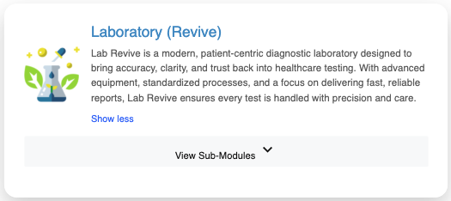
The platform plays a critical role in delivering quality healthcare services, as accurate and real-time patient data is essential for clinical decision-making and administrative management. Health Suite integrates all core hospital modules — including OPD, IPD, Laboratory (Legacy & Revive), Procedure Management, Pharmacy, Patient Data Record System, Accounts, and Configurer — providing a unified view of institutional operations.
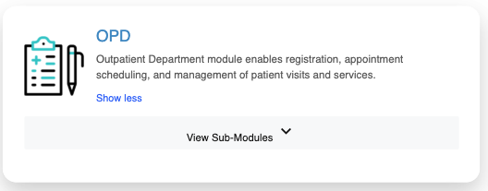
Furthermore, the system ensures that medical and financial data is securely stored, role-based access is maintained, and information is readily available to authorized personnel for review, reporting, and analysis. By centralizing healthcare operations, Health Suite enhances service delivery, improves transparency, and supports efficient hospital management.
  - Core Modules:
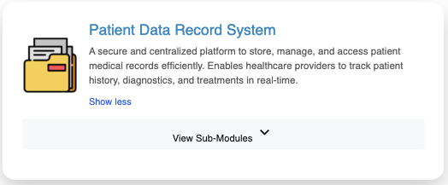
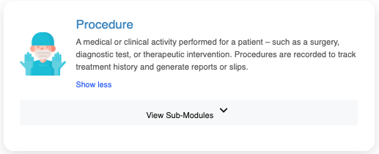
The Origami’s Health Suite is built around a set of fully integrated core modules designed to manage the complete lifecycle of hospital operations — from patient registration to diagnostics, treatment, pharmacy dispensing, and financial management. These modules work together within a centralized platform to ensure seamless data flow, operational efficiency, and high-quality patient care.
- OPD (Outpatient Department)
- IPD (Inpatient Department)
- Laboratory (Legacy & Revive)
- Procedure Management
- Pharmacy
- Patient Data Record System (PDRS)
- Accounts
- Configurer

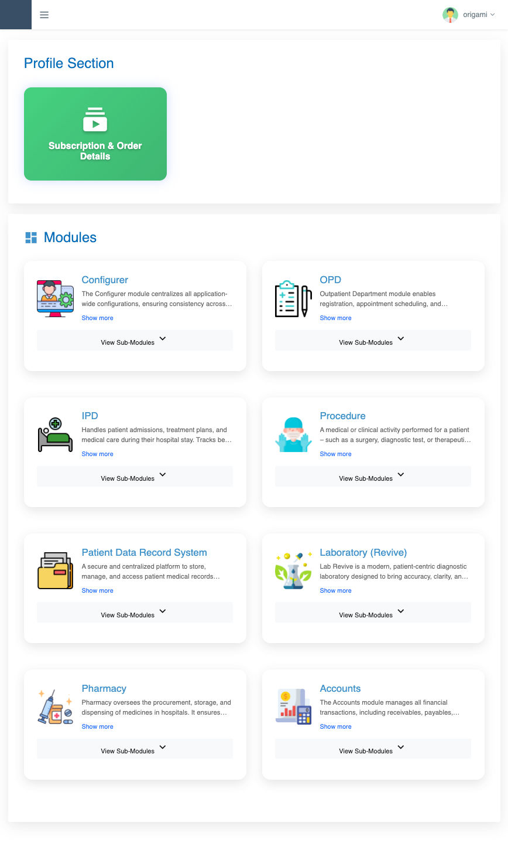
- Admin Login
The Admin Login screen serves as the secure gateway for authorized administrators to access Origami’s Health Suite platform. The interface is designed to provide a simple, secure, and efficient login experience. Administrators are required to enter their registered credentials (User ID and Password) to authenticate and access the system.
Upon successful login, the Admin gains complete access to all modules subscribed under the Health Suite platform. The Admin dashboard provides a centralized view of:
- All purchased modules
- Configuration settings (via Configurer module)
- Subscription details
- Invoice download options
- Payment and transaction history
  - Admin Dashboard – Module & Configuration Access
After login, the Institutional Admin can:
View all 9 subscribed modules, including:
  - OPD
  - IPD
  - Laboratory (Legacy)
  - Laboratory (Revive)
  - Procedure
  - Pharmacy
  - Patient Data Record System
  - Accounts
  - Configurer
- Access the Configurer module to manage master data, tariff configuration, workflows, departments, user roles, and system settings.
- View complete Configuration Details of the institution.
- Download the Invoice and Order Receipt.
- Review subscription validity and payment history.
The Admin Dashboard provides a dedicated section for viewing Order and Payment Details to ensure transparency and proper financial tracking. It displays key information such as Order ID, total amount paid (including GST), base amount, currency, transaction date and time, payment gateway details (Razorpay), receipt number, and payment status. The system also shows the associated Subscription ID, subscription type (Yearly), total duration (36 months), subscription validity period (start and end date), total modules covered under the plan, and the total price paid. This enables administrators to verify subscription validity and payment confirmation at any time.
In addition, the dashboard maintains complete Client Information, including the client name, nature of enterprise (Health Care Facility – Hospitals/Clinics), registered address, contact number, email ID, and GSTN status. By consolidating order, subscription, and client details within a single interface, the Admin Dashboard ensures structured record management, easy invoice access, and centralized oversight of system configuration and module activation within the Health Suite platform.
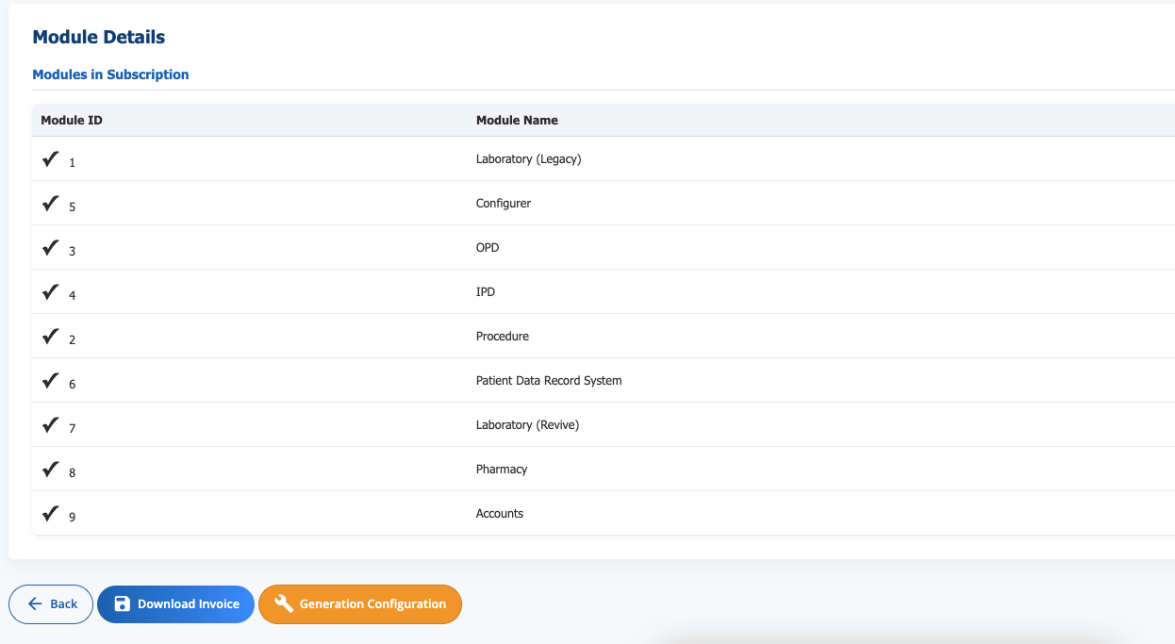

- Configurer Module
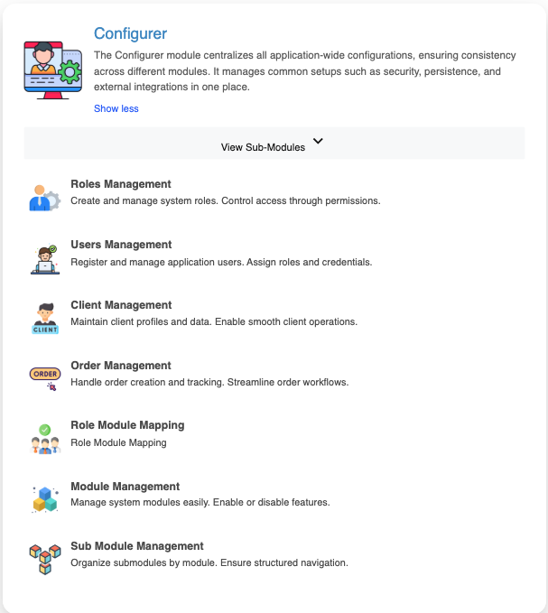
The Configurer module serves as the central control panel of the Health Suite platform, enabling administrators to manage all system-wide configurations from a single interface. It ensures consistency, security, and structured management across all modules by handling key setups such as role definitions, user access, module activation, and operational controls. Through Roles Management and Users Management, administrators can create system roles, assign permissions, register users, and manage credentials to maintain secure and role-based access throughout the application.
In addition, the Configurer module supports Client Management for maintaining client profiles, Order Management for tracking and managing subscriptions, and Role Module Mapping to control module-level access based on assigned roles. It also includes Module Management and Sub-Module Management, allowing administrators to enable or disable features and organize system components in a structured manner. This centralized configuration framework ensures smooth operations, secure access control, and efficient platform governance within Health Suite.
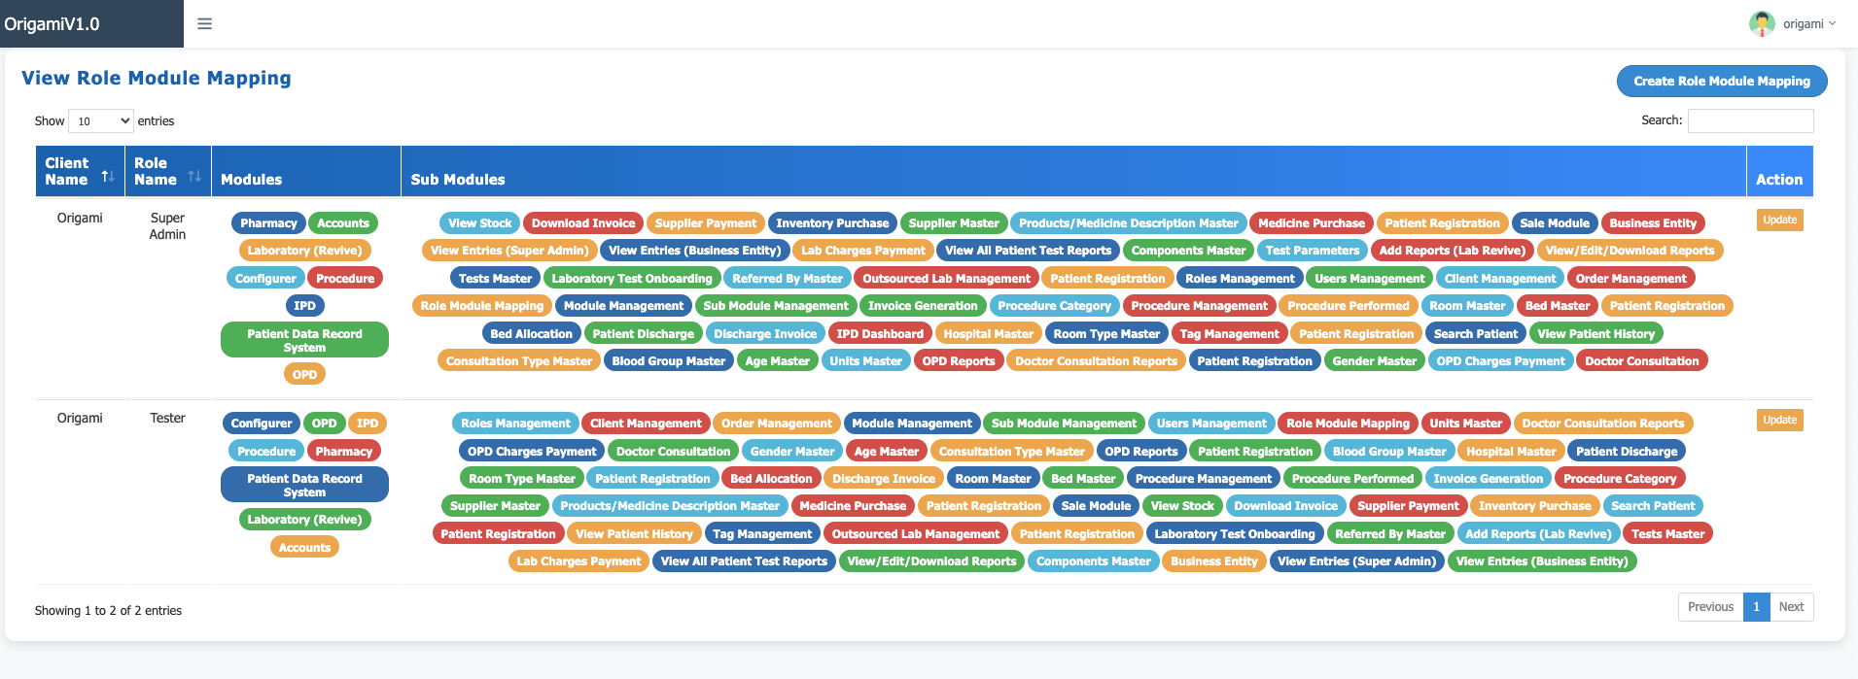
The View Role Module Mapping section provides a comprehensive overview of module and sub-module access assigned to each role within the Health Suite platform. It displays client-wise role configurations (e.g., Origami – Super Admin, Tester) along with the complete list of accessible modules such as OPD, IPD, Laboratory (Revive), Pharmacy, Procedure, Accounts, Patient Data Record System, and Configurer. For each role, the mapped sub-modules—such as Patient Registration, Invoice Generation, Bed Allocation, Supplier Management, Test Parameters, Report Management, and Stock Operations—are clearly listed, ensuring transparent access control. This feature enables administrators to verify permissions, maintain security through structured role-based access control (RBAC), and ensure that users can access only the functionalities relevant to their responsibilities.
The User Management section within the Configurer module enables administrators to create and manage system users in a structured and secure manner. While creating a new user, the Admin enters essential details such as First Name, Last Name, Username, Mobile Number, Gender, Permanent Address, Email, and WhatsApp Number. The Admin then assigns an appropriate role from the predefined role list and sets a secure password with confirmation to ensure proper authentication. Additionally, documentary proof such as a user photograph is uploaded for identity verification and record maintenance. This structured user creation process ensures accurate user profiling, secure credential management, and effective role-based access control within the Health Suite platform.

The Sub Module Management section provides a detailed view of all configurable sub-modules available within the Health Suite platform. Each entry displays the Sub Module ID, Sub Module Name, Price, Description, associated Module Name, and its Active/Inactive status, allowing administrators to monitor and control feature availability. Examples include Roles Management, Users Management, Client Management, Order Management, Test Management, Outsourced Lab Management, Referred By Management, and Patient Registration. This structured listing ensures clarity in feature organization and simplifies system administration.
In total, the Health Suite platform consists of 9 core modules, collectively comprising 70+ sub-modules designed to cover all operational aspects of a healthcare facility. This modular architecture allows flexible configuration, controlled access, and scalable deployment, enabling healthcare institutions to activate only the required features while maintaining a well-organized and efficiently managed system environment.

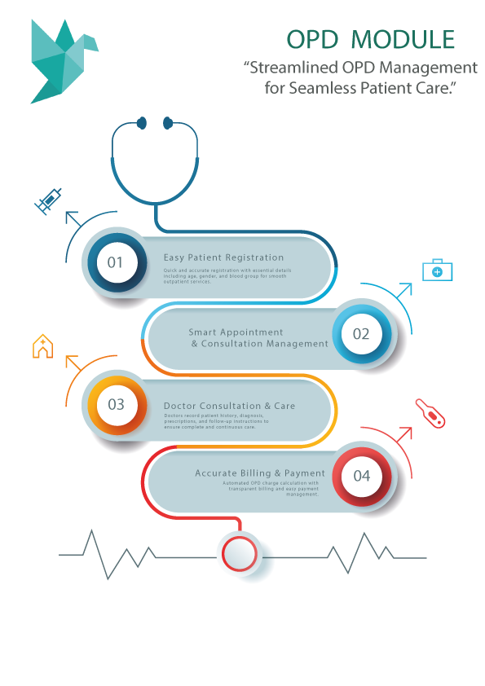
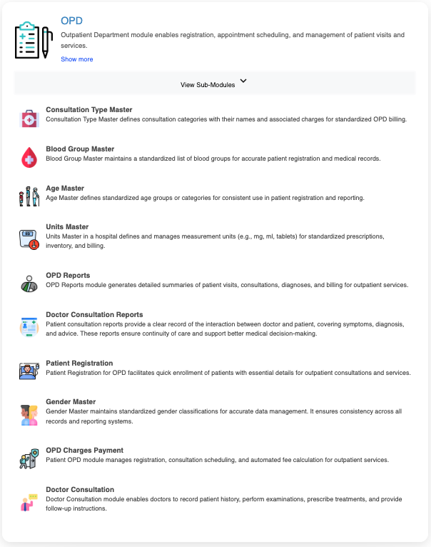
- OPD
The OPD (Outpatient Department) Module in Health Suite enables complete management of outpatient services, starting from patient registration to consultation, billing, and reporting. It includes essential master configurations such as Consultation Type Master (to define consultation categories and charges), Blood Group Master, Age Master, Gender Master, and Units Master, ensuring standardized and accurate data entry across the system. The module also provides Doctor Consultation, where doctors can record patient history, symptoms, diagnosis, prescriptions, and follow-up advice, along with OPD Charges Payment for automated fee calculation and payment recording (cash/online). Additionally, OPD Reports and Doctor Consultation Reports generate structured summaries of visits, diagnoses, and billing, supporting medical continuity and administrative monitoring.

The Patient Registration feature is a common and reusable component across all major modules of Health Suite, including OPD, IPD, Laboratory, and Procedure. Registration can be performed through both web and mobile interfaces, ensuring flexibility and accessibility for healthcare staff. While creating a new patient record, mandatory fields such as Patient Name, Gender, Age, Age Type, Mobile Number, and Emergency Contact must be accurately entered to maintain reliable medical records. Once saved, the system generates a unique Patient ID and creates a structured patient profile containing demographic and clinical reference information such as blood group and contact details.
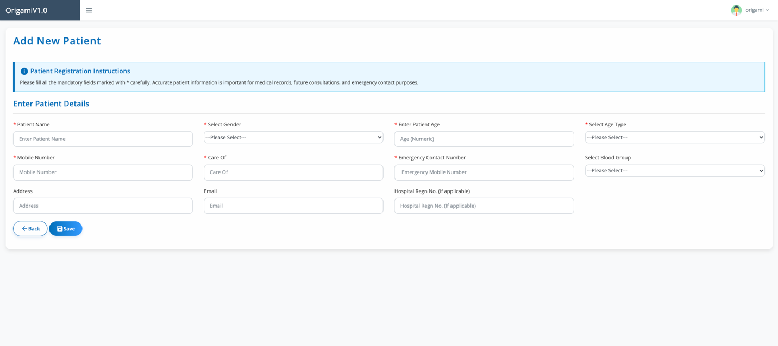

In the first scenario, users can search for a patient using the registered mobile number during OPD charge entry. Upon entering the mobile number, the system automatically fetches and displays the patient’s profile details, eliminating the need for duplicate data entry. The user can then select the appropriate consultation type, after which the system calculates the predefined consultation charges. Payment details (cash/online) can be recorded immediately, ensuring a smooth and time-efficient billing workflow.
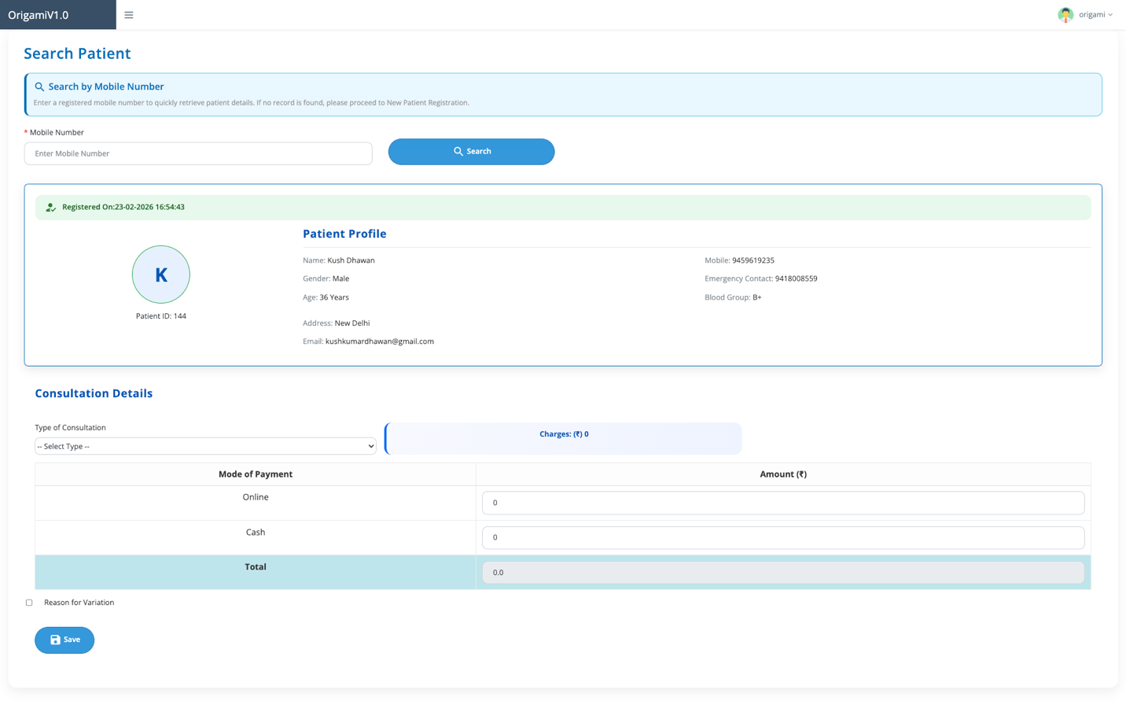

In the second scenario, users can view the list of registered patients with the same Mobile Number, which is displayed in descending order based on date and time (most recent registrations first). The list can be sorted and searched as required. After selecting the desired patient from the list, the user can proceed with consultation entry and charge processing by choosing the consultation category. This structured approach ensures flexibility in patient lookup, quick charge entry, accurate billing, and seamless outpatient service management within the Health Suite platform.

Within the Doctor Consultation Module, once a patient is selected through mobile search or from the patient list, all previously recorded demographic and registration details are automatically prefilled on the consultation screen. This includes basic information such as Patient Name, Age, Gender, Mobile Number, and other profile details, allowing the doctor to focus directly on clinical documentation without re-entering existing data. The system ensures continuity by displaying past records where applicable, supporting informed medical decision-making.

The doctor can then enter or update detailed consultation information, including Chief Complaint, History of Present Illness, Past Medical History, and General Examination findings such as height, weight, blood pressure, pulse, temperature, and respiratory rate with proper measurement units. Additional fields like Diagnosis, Treatment Plan, Noteworthy Investigation Results, and Follow-up Date must be completed as required. The system clearly highlights mandatory fields to ensure that essential medical data is captured before submission.
All information displayed on the consultation screen can be reviewed and updated in real time during the patient interaction. This dynamic data entry capability allows corrections or additions before final saving, while maintaining structured medical records. Once submitted, the consultation details become part of the patient’s permanent history, accessible to authorized users for future reference, reporting, and continuity of care within the Health Suite platform.

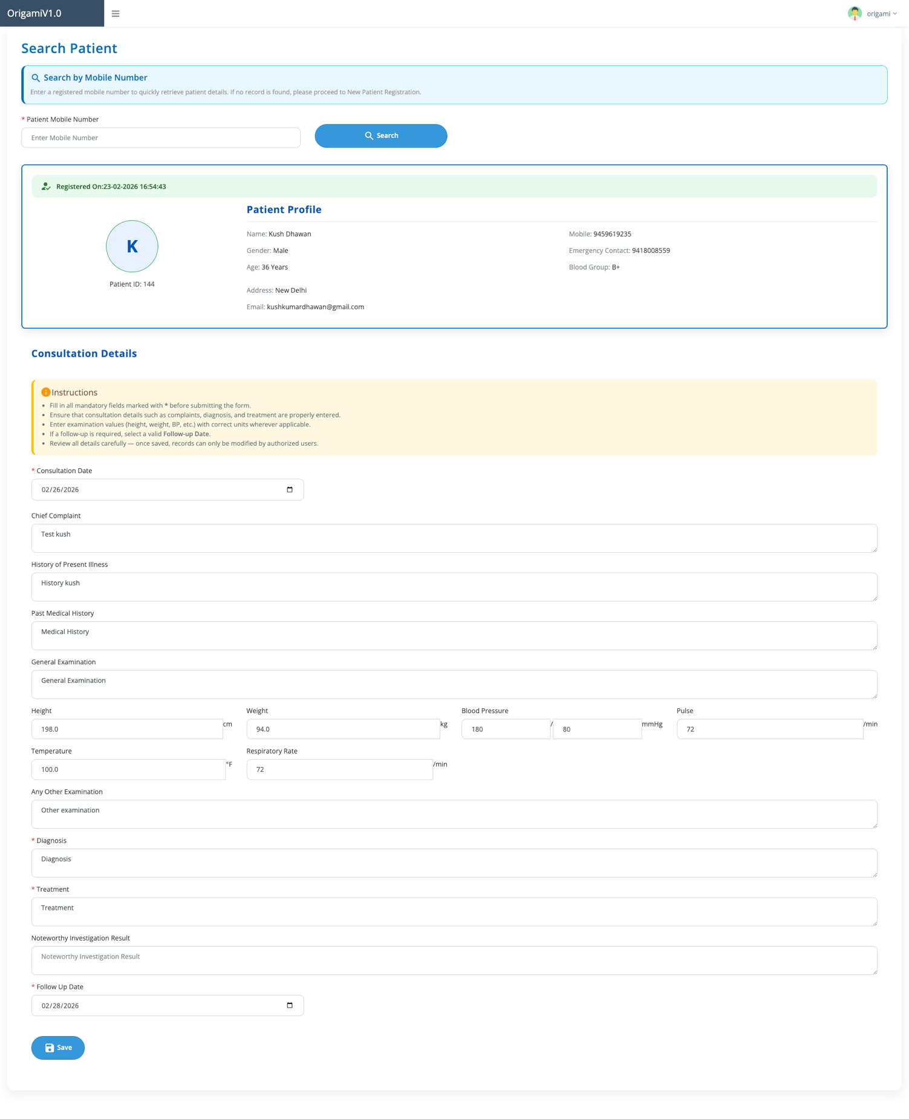

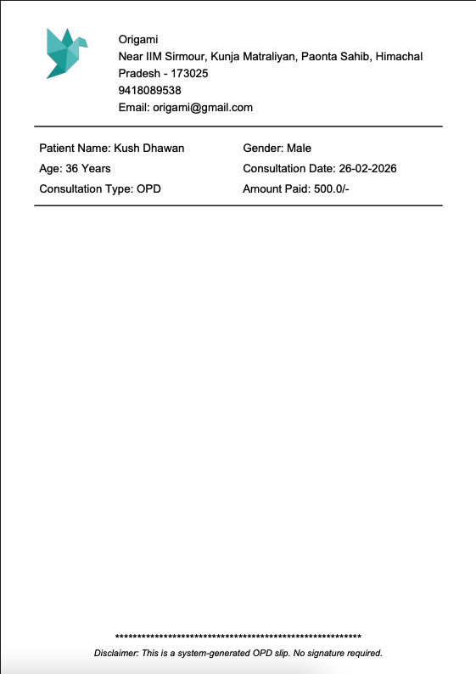
Upon successful payment of the consultation fee, the patient will receive a system-generated OPD consultation slip along with the official invoice and payment slip. These documents serve as confirmation of the visit and payment, include consultation details, and can be safely retained for medical records, reimbursement, or future reference.

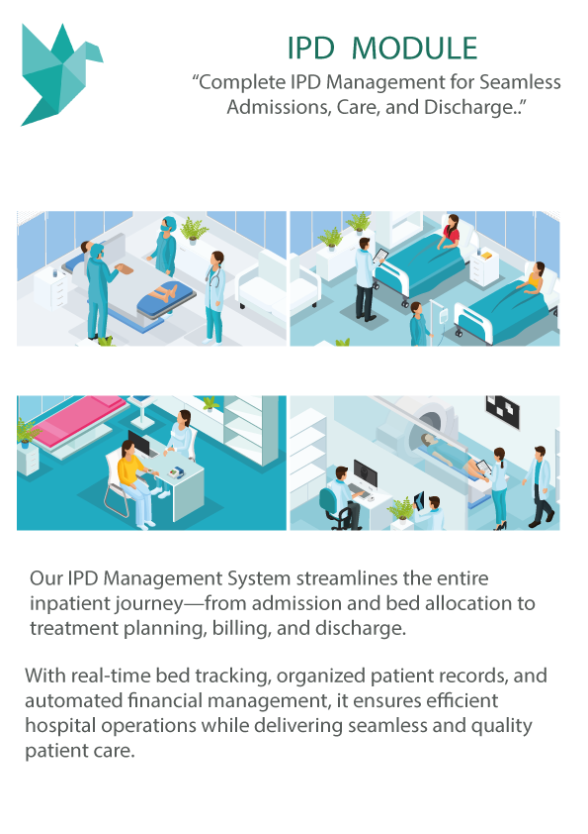
- IPD
The IPD (In-Patient Department) Module in Health Suite manages the complete lifecycle of hospitalized patients, from admission to discharge and final billing. It includes structured masters such as Hospital Master, Room Type Master, Room Master, and Bed Master, which define hospital infrastructure including room categories (Special, Deluxe, General, ICU), room numbers, floor locations, and bed mappings. These masters enable accurate bed tracking and real-time visibility of occupancy. The IPD Dashboard provides a consolidated view of current admissions, vacant and occupied beds, discharges, and pending actions, ensuring smooth operational control.
The admission process follows a streamlined workflow similar to OPD. Staff can search for an existing patient using the registered mobile number or select from the patient list, which is typically sorted in descending order by date and time. If the patient is new, registration can be completed instantly. Once selected, the patient can be admitted by assigning a doctor, selecting the appropriate room type, and proceeding with Bed Allocation based on availability. The system ensures that only vacant beds are shown for selection, maintaining real-time accuracy in occupancy tracking.
During the patient’s stay, all treatments, procedures, and services are recorded and automatically linked to billing. Room charges are calculated based on the selected room type and duration of stay, while procedure charges are integrated directly from the Procedure module. At the time of Patient Discharge, the system generates a comprehensive Discharge Invoice, including room rent, doctor fees, procedures, laboratory tests, medicines, and other services. This automated calculation ensures accurate billing, financial transparency, and efficient case closure within the Health Suite platform.

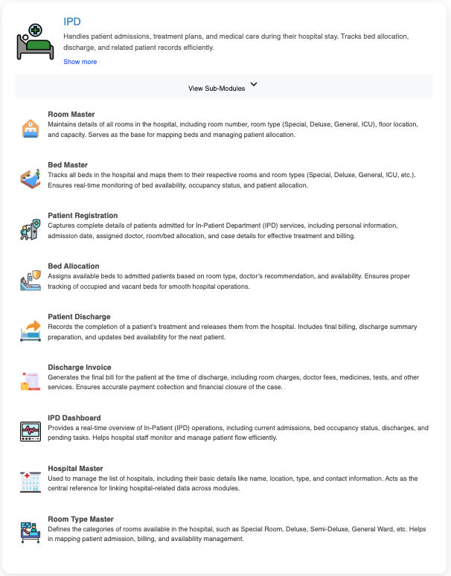
The Administrator has full control over room configuration within the IPD module. The Admin can create and manage rooms through the Room Master, define room types, set room-wise pricing, and view the complete list of available rooms along with their current status.
The system uses color indicators for easy identification: Red represents occupied rooms/beds, Green indicates available (free) rooms/beds, and Yellow highlights that the selected patient is already assigned to that particular room. This visual status management ensures quick decision-making, prevents double allocation, and enhances operational efficiency in patient admission and bed management.
In addition, the Search Patient functionality within the IPD module ensures a smooth admission workflow by allowing staff to retrieve patient details instantly using the registered mobile number. Once the patient profile is displayed—including demographic details, contact information, and blood group—the admission process can proceed without redundant data entry. If no record is found, the system prompts for New Patient Registration, maintaining continuity of service. During admission, authorized staff must select the appropriate admission option, date, and diagnosis, along with remarks if required. The system clearly indicates if no bed is allotted, prompting users to proceed with bed allocation to complete the process.
The module also incorporates structured Hospital Charges Instructions to ensure billing accuracy and compliance with hospital policies. Staff must carefully select the correct room type and room number, verify room charges in INR (₹), and ensure all applicable costs—such as bed and nursing charges—are included. Only authorized personnel can modify charges, reducing the risk of billing discrepancies. By combining patient search, admission control, bed allocation alerts, and guided charge entry, the IPD module strengthens operational transparency and ensures accurate inpatient management within the Health Suite platform.

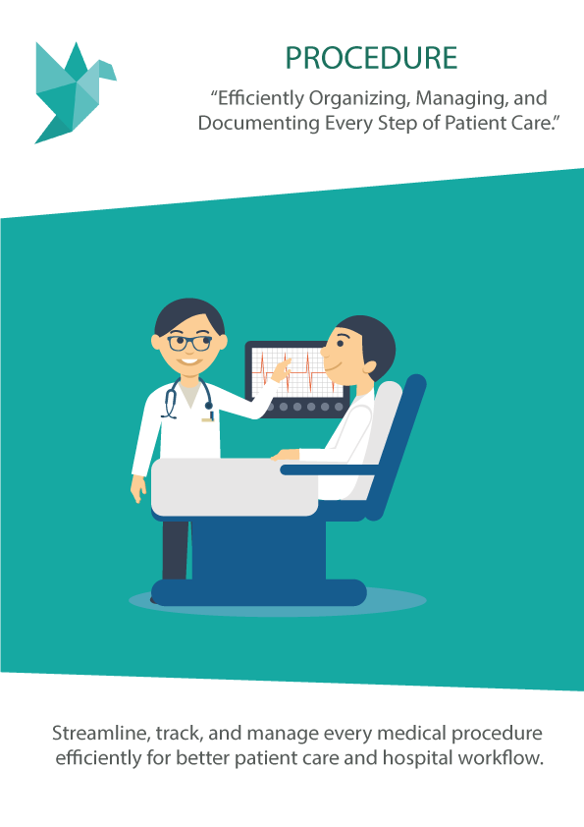
- Procedure
The Procedure Module in Health Suite is designed to manage and record all medical and clinical procedures performed for patients, such as surgeries, diagnostic interventions, and therapeutic treatments. It ensures that every procedure is systematically documented with complete details including patient information, procedure name, date, assigned doctor or surgeon, and relevant remarks. By digitizing procedure records, the module creates a structured treatment history that can be referenced for clinical decision-making, reporting, and billing purposes.
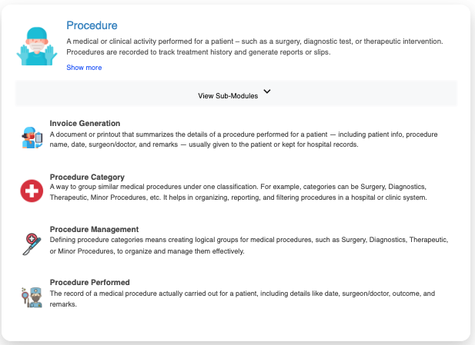

The module includes key components such as Procedure Category, which organizes procedures into logical groups like Surgery, Diagnostics, Therapeutic, or Minor Procedures for better classification and reporting. Through Procedure Management, administrators can define and configure procedures under appropriate categories, assign charges, and standardize service listings. The Procedure Performed section captures the actual execution details for each patient, ensuring accurate documentation of medical interventions carried out within the facility.
Additionally, the Invoice Generation feature automatically prepares a structured invoice or procedure slip summarizing patient details, procedure name, doctor, date, and applicable charges. This supports transparent billing, financial tracking, and proper record maintenance. Overall, the Procedure Module enhances clinical documentation accuracy, improves operational organization, and ensures seamless integration of medical services with the billing and reporting systems within the Health Suite platform.
In addition to structured configuration and billing integration, the Procedure Module follows a streamlined workflow for recording procedures. Users can begin by searching for the patient using the registered mobile number, which instantly retrieves the patient’s profile and demographic details. This ensures that procedures are correctly mapped to the existing patient record and avoids duplication. If the patient is not found, new registration can be completed before proceeding further, maintaining continuity in documentation.
Once the patient is selected, the Procedure Performed form enables detailed clinical entry, including Date of Procedure, Procedure Type, Nature of Procedure (e.g., Elective or Emergency), Name of Procedure, Surgeon, Anaesthesiologist, Assistant, Outcome, and Remarks. Mandatory fields must be completed before submission to ensure complete medical documentation. Upon saving, the procedure becomes part of the patient’s treatment history and can be linked automatically with billing for invoice generation. This structured workflow ensures accurate record-keeping, financial transparency, and seamless coordination between clinical and administrative functions within the Health Suite platform.

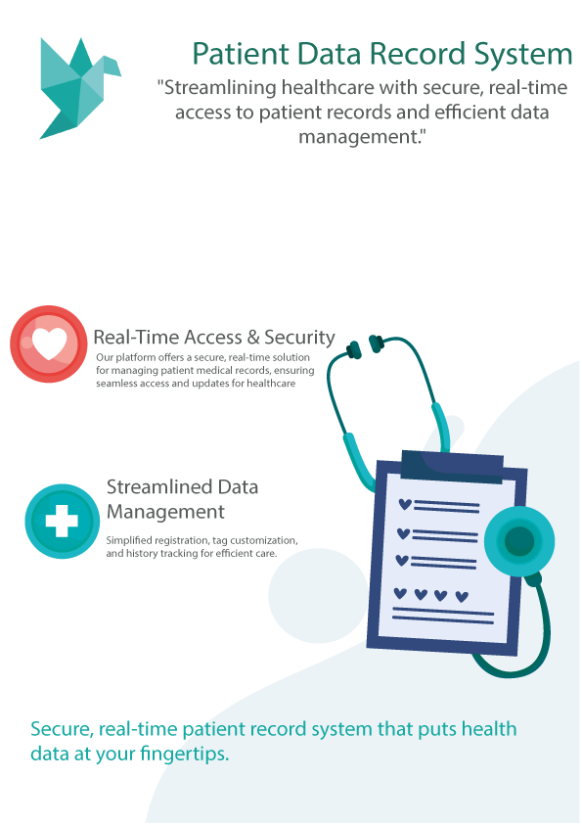
- Patient Record Data System
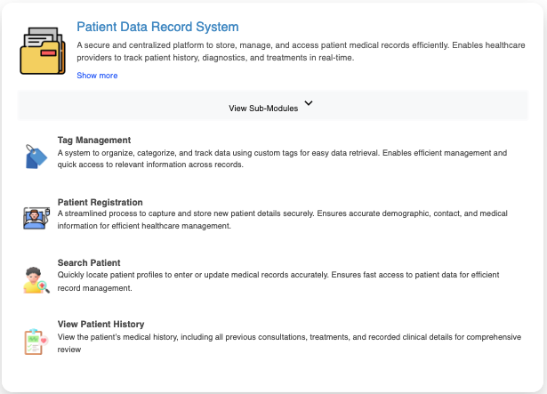
The Patient Data Record System (PDRS) is a secure and centralized digital repository designed to store, manage, and provide real-time access to comprehensive patient medical records. It enables healthcare providers to track a patient’s complete medical journey—including consultations, admissions, procedures, diagnostics, and billing—within a single integrated platform. By maintaining structured and role-based access to patient information, the system ensures data security, accuracy, and continuity of care across departments.
The module includes essential features such as Patient Registration, Search Patient, and View Patient History. Patient Registration captures accurate demographic, contact, and medical details to create a secure digital profile. The Search Patient functionality allows quick retrieval of records using identifiers like mobile number, ensuring efficient data access. View Patient History provides a consolidated timeline of previous consultations, diagnoses, procedures, lab reports, and treatment summaries, enabling doctors to make informed clinical decisions based on historical data.
The PDRS is fully integrated with the Mobile Application, ensuring seamless real-time synchronization between web and mobile platforms. Healthcare staff can update patient records on one interface and instantly view changes on the other without manual intervention. This real-time data sync enhances operational efficiency and ensures that medical information is always current and accessible to authorized users.
The mobile platform is camera-enabled, allowing users to capture and upload OPD slips, prescriptions, diagnostic reports, or historical medical documents directly from the device camera or gallery. The system supports intelligent file compression to optimize storage and ensure fast uploads without compromising document clarity. This feature is particularly useful for maintaining digital backups of physical records and improving documentation completeness.
Additionally, Tag Management enables categorization and structured organization of patient records using custom tags for faster retrieval and filtering. By combining centralized storage, mobile accessibility, real-time synchronization, document upload capabilities, and intelligent data organization, the Patient Data Record System strengthens digital healthcare management and enhances patient engagement within the Health Suite ecosystem.

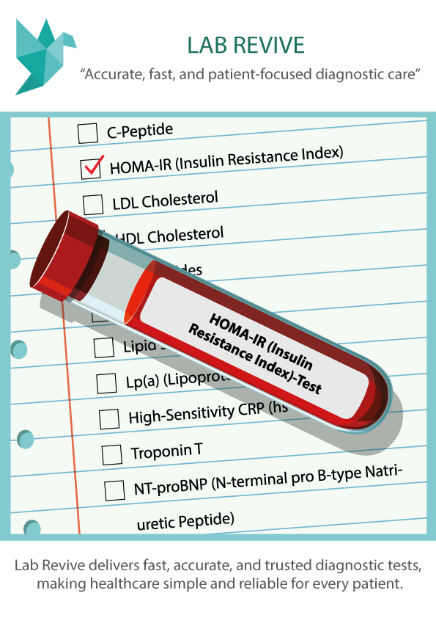
- Lab Revive
The Laboratory (Revive) module in Health Suite is a modern, patient-centric diagnostic management system designed to ensure accuracy, reliability, and efficiency in laboratory operations. It manages the complete diagnostic lifecycle—from test configuration and patient onboarding to sample processing, report generation, and billing. With standardized parameter definitions, structured workflows, and integrated billing, Lab Revive enhances both clinical precision and administrative transparency within healthcare facilities.
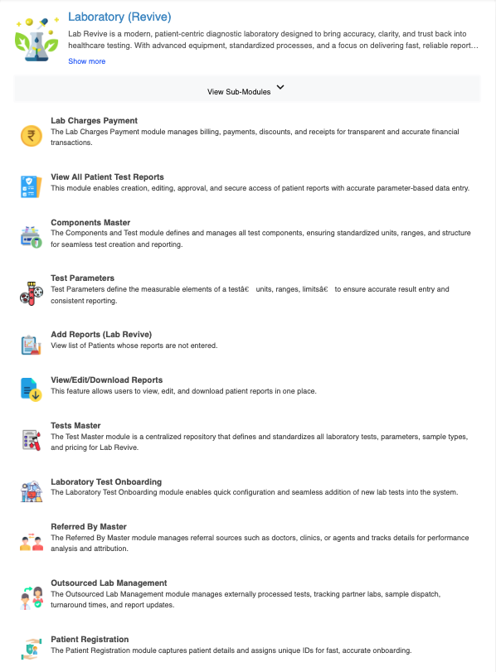

The module is supported by structured masters such as Tests Master, Components Master, and Test Parameters, which define laboratory tests, measurable components, units, reference ranges, and pricing. The Laboratory Test Onboarding feature allows quick addition of new tests, while Referred By Master manages referral sources such as doctors or clinics for tracking and reporting purposes. For tests processed externally, the Outsourced Lab Management module tracks partner laboratories, sample dispatch, turnaround time, and report updates, ensuring full visibility even for outsourced diagnostics.
The workflow begins with Search Patient for Adding Tests, where staff can retrieve patient details instantly by entering the registered mobile number. If the patient exists, their complete profile—including Patient ID, demographic details, and contact information—is displayed. If not found, new patient registration can be completed seamlessly. This ensures that all diagnostic services are accurately mapped to the correct patient record without duplication.
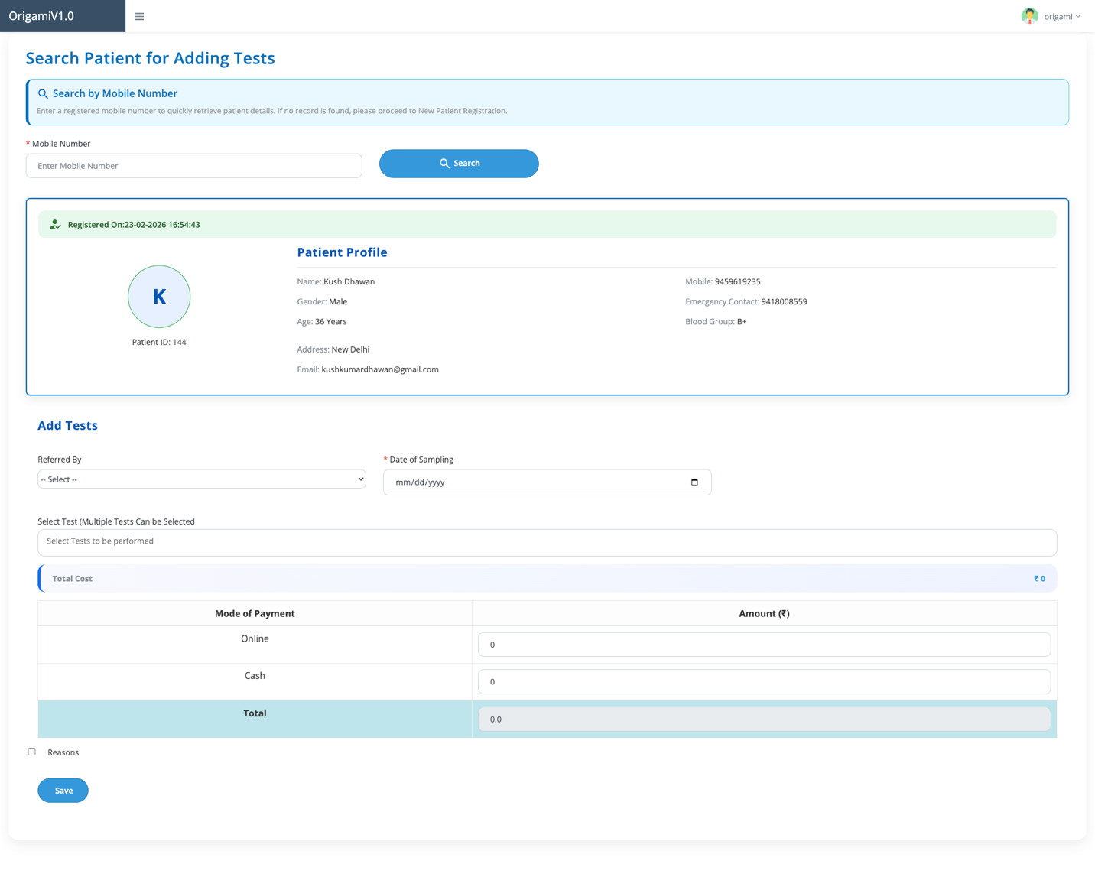
Once the patient is selected, users can proceed to Add Tests, where multiple laboratory tests can be selected simultaneously for a single patient. The form includes fields such as Referred By, Date of Sampling, and test selection from a predefined list. The system automatically calculates the Total Cost based on selected tests. Users can then record payment details by specifying mode of payment (Online/Cash) and amount received, along with reasons if applicable. This integrated billing process ensures financial transparency and reduces manual calculation errors.
After sample collection and processing, authorized laboratory staff can use Add Reports (Lab Revive) to enter parameter-wise results. Reports can then be reviewed, edited, approved, and accessed securely through the View/Edit/Download Reports feature. This structured reporting mechanism ensures standardized result entry, accurate interpretation based on defined reference ranges, and professional report generation for patients and doctors.
Overall, the Laboratory (Revive) module streamlines diagnostic management by combining patient search, multi-test assignment, structured parameter entry, outsourced lab tracking, and integrated billing within a single platform. By enabling precise test configuration, real-time patient mapping, and secure report handling, Lab Revive strengthens diagnostic accuracy, operational efficiency, and patient trust within the Health Suite ecosystem.

The View Tests section in the Laboratory (Revive) module provides a structured listing of all configured laboratory tests within the system. Each entry displays key details such as Test ID, Test Name, Test Type (In-House/Out-House), associated Test Components, and defined Test Parameters. The interface supports pagination and search functionality, allowing users to quickly locate specific tests from the total configured list. This centralized test repository ensures standardized test definitions and simplifies test selection during patient sample entry.
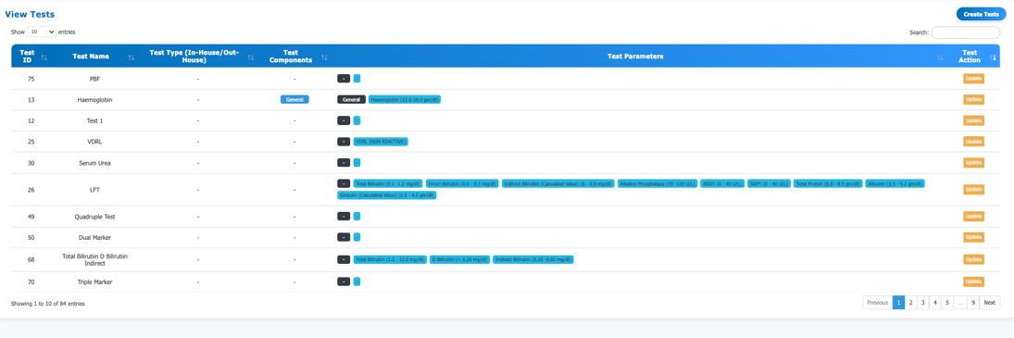

Within the system, test parameters are logically classified under components, which act as grouping structures for related measurable values. For example, a test like LFT (Liver Function Test) includes multiple parameters such as Total Bilirubin, SGOT, SGPT, Albumin, and others, each defined with standardized units and reference ranges. These parameters are first organized under components and then displayed in a structured format during report entry and generation. This classification ensures clarity in result recording, consistent reporting standards, and accurate interpretation of diagnostic outcomes within the Health Suite platform.

The Create Tests functionality in the Laboratory (Revive) module enables administrators to define and configure new laboratory tests in a structured manner. While creating a test, the user must enter the Test Name and Test Description, followed by adding multiple test parameters as required. The system allows grouping of parameters under selected components to maintain logical classification and standardized reporting. This ensures that each test is properly structured before being made available for patient assignment and report generation.

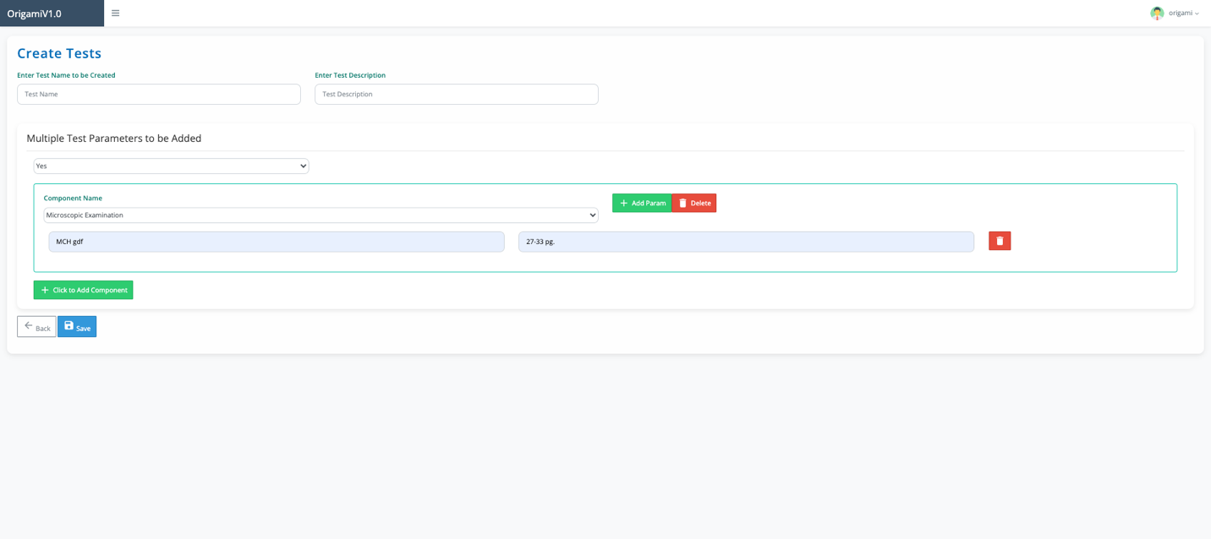

Test parameters are organized through the Components Master, where components can be created and managed separately. During test creation, the user selects a Component Name from the predefined list and then defines individual Parameter Names along with their reference Ranges. Multiple components and multiple parameters can be added within a single test, allowing comprehensive configuration for complex diagnostics. This modular approach ensures clarity, accuracy, and consistency in laboratory test setup within the Health Suite platform.

The Laboratory Test Onboarding feature in the Laboratory (Revive) module allows administrators to configure new diagnostic tests with complete pricing and processing details. While creating a test (e.g., Quadruple Test), the user must define the Test Price (in Rupees, including GST) to ensure accurate billing during patient test assignment. This standardized pricing structure ensures transparency and seamless integration with the Lab Charges Payment module.
Additionally, the system requires the user to specify whether the test is conducted In-House or Out-House. If marked as an Out-House Test, the administrator must select the appropriate option and define the Outsourced Test Cost, enabling proper financial tracking and margin calculation for externally processed diagnostics. This structured configuration ensures clarity in operational handling, cost management, and billing accuracy within the Health Suite laboratory workflow.

The Search Patient (Add Report) feature in the Laboratory (Revive) module allows laboratory staff to retrieve patient records using the registered mobile number before entering test results. If no patient is found with the entered mobile number, the system displays a warning message and prompts the user to proceed with New Patient Registration. This ensures that reports are always mapped to valid and existing patient records, preventing data inconsistencies.
Reports can only be added for tests where parameter values are pending or not yet entered. Once all test parameters are completely filled by the Lab Admin, the report becomes available for viewing and editing (subject to role-based permissions). Editing and downloading of reports are permitted only after complete parameter entry, ensuring accuracy, validation, and integrity of diagnostic results within the Health Suite platform.

- Access Controls, Privacy and Security
  - Privacy
The Origami Health suite ensures strict privacy protocols, safeguarding the personal information of all families registered on the platform. All data collected, including Tests details and personal details, will be processed in accordance with relevant privacy laws. Personal data will only be used for the purposes intended and will not be shared with external parties without prior consent, unless required by law. The platform conducts regular audits to ensure privacy standards are maintained, and necessary measures are taken to prevent unauthorized access or misuse of data.

  - Security
Security is a top priority for the Origami Health Suite. All sensitive information, including personal of the Patient, is encrypted using the latest security standards. Continuous monitoring ensures the system can quickly detect any suspicious activity or potential breaches. If a security issue arises, the affected user accounts will be temporarily locked, and immediate steps will be taken to notify users. Regular security assessments are conducted to address vulnerabilities and maintain robust protection against evolving threats.

  - Access Control
Origami Health Suite implements Role-Based Access Control (RBAC) for Institutions/Hospitls, restricting access to specific data based on their roles and responsibilities. The platform uses an Identity and Access Management (IAM) system to dynamically adjust access rights as roles change, ensuring that access to sensitive information is controlled and minimized. These measures help maintain a secure environment, preventing unauthorized access and enhancing the overall security of the system.

